1 PAGE, TASK 1: Leadership and Negotiation, DUE SEP 27, 9PM
You will compose a block-style letter in response to the company email you recently received. The business letter should be addressed to Mr. Bezos, the CEO of Amazon. As you consider your response, do not forget to apply the Rogerian argument. You should remember to maintain an objective stance, use neutral language, and seek compromise. Good negotiating skills are valued highly in the workplace, and your ability to compromise is an important life skill.
This is Company Email:
You have worked for Amazon in the corporate office for six years, but you have not had an increase in salary for over five years. You have a strong work ethic, and you are rarely out of the office for illness. You recently discovered the rent on your condo has gone up by 15%; and yet, your salary has remained the same, $80,000 per year. Despite not receiving a raise, you enjoy working at Amazon, and you have contributed to distribution innovation and online business networking. Your contributions contributed to Amazon’s 40% increase in profit. Moreover, your contributions were recognized by Mr. Bezos, the company CEO. Although the company has over 300,000 employees worldwide, the company has continued to gain market share and increased profits.
You have never considered leaving Amazon, for the company benefits are excellent; you have 401K options, tuition assistance, 24 days of leave, and financial aid repayment assistance. Recently, however, the company human resource department has communicated there will be no raises for next year, despite increased company profits. Mr. Bezos, the company CEO, stated that increased costs in shipping, distribution, theft, and production costs have contributed to Amazon’s inability to support salary increases across the company. Moreover, Amazon has pledged to increase its fleet of automated cars as a way to reduce employee hours at distribution centers across the country. The rising cost of employee benefits, especially health benefits, has also contributed to Amazon’s inability to support salary increases. You remain cautiously optimistic and are seeking ways to change your present circumstances.
Jeff Bezos, President
Amazon Headquarters
410 Terry Ave. North
Seattle, WA 98109-5210

1 PAGE, TASK 2, DUE SEP 29, 9PM
Performance Task: Composing a Rogerian Argument in a Form of Letter

Instructions:
Performance Task: A group of parents and teachers in your school has made a proposal to the school board. In their proposal, they are suggesting that the school join in a national movement called “Shut Down Your Screen Week.” The parents and teachers in the group believe that not using any electronic media for an entire week would be good for students for many reasons. They have taken the proposal to a teachers’ meeting so that teachers can discuss the issue of whether or not to ask their students to participate in the “Shut Down Your Screen Week.” The teachers have decided they would like to hear from the students before they decide.
- This is not a simple issue, so you need to think very carefully about it. You have four texts to read relating to the issue: “Social Media as Community (Links to an external site.),” “Is Google Making Us Stupid? (Links to an external site.),” “Attached to Technology and Paying a Price (Links to an external site.),” and “An Ugly Toll of Technology: Impatience and Forgetfulness (Links to an external site.).” To compose your response, you will use the four texts!
- As you read and/or annotate these texts, think about what they show you about the issue. Think about what position you will take and what evidence you will use to support your thinking. You must use all four texts to compose your argument, and you must use in-text citations when quoting, paraphrasing, or summarizing source materials. You may use your APA Pocket Manual. You must also include a separate reference page.
- Finally, write a Rogerian argument essay, in the form of a letter to share with teachers and administrators explaining your thinking. You will present the student’s perspective, for most students do not wish to turn off their cell phones.
Mailing Address:
Methodist High School
1256 Academic Drive
Fayetteville, NC 28311

Guidelines
Performance Task: Composing a Rogerian Argument
Format: APA
Other Requirements: Letter (e.g. Date, Greeting, Block Style, Closing)
Length: Minimum 1 page (275+ words)
Purpose: Write arguments to support claims in an analysis of substantive topics or texts using valid reasoning and relevant and sufficient evidence.

Please follow this Rogerian organizer here!
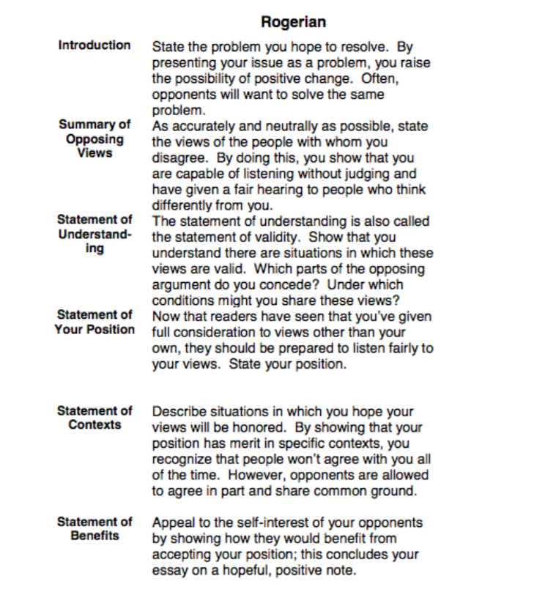

1.2-2 PAGES (at least 200 words on each), TASK 3: SHORT QUESTIONS, DUE 0CT 07, 11PM
- Is Christina Rossetti's "Goblin Market" just a fairy tale poem about a couple of sweet young farmer girls and some goblins and fruit, or might there be something more complicated going on beneath the surface? What if I told you that this very poem, written by a Victorian woman in the 1850s, was actually published along with some graphic illustrations in a 1973 issue of Playboy magazine? How might that change your reading of Rossetti's poem? Any specific examples from the poem that stuck out to you while reading it?
- After reading Walter Pater’s “Conclusion” from Studies in the History of the Renaissance in the Norton Anthology, as well as "The Preface" at the beginning of Oscar Wilde's The Picture of Dorian Gray, discuss what you think both of these writers were trying to say in each of those pieces? What is your interpretation of Pater and Wilde in terms of what they think about art and morality, in relation to the "Conclusion" and "The Preface"?

Additional Info:
Christina Rossetti's "Goblin Market": https://www.poetryfoundation.org/poems/44996/goblin-market

"The Preface" at the beginning of Oscar Wilde's The Picture of Dorian Gray:
https://www.d.umn.edu/~cstroupe/handouts/8906/wilde_preface_dorian_gray.pdf

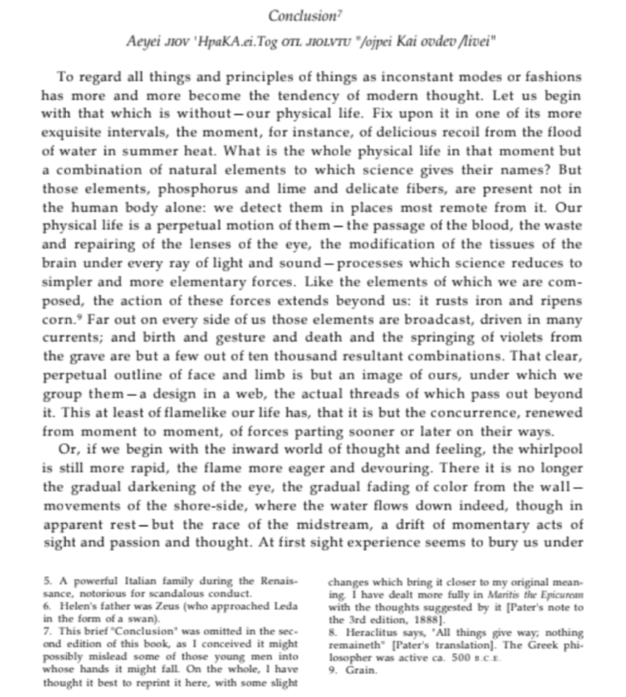
Walter Pater’s “Conclusion”:
